**Design Document**

|  |  |
| --- | --- |
| Tentative Title: | Get Ball |

**1**

|  |
| --- |
| 04|11|2022  M. Rizal Perdana Putra |

**App Info**

|  |  |  |  |  |  |  |  |  |  |  |  |  |  |  |  |  |  |  |
| --- | --- | --- | --- | --- | --- | --- | --- | --- | --- | --- | --- | --- | --- | --- | --- | --- | --- | --- |
| |  |  | | --- | --- | |  | Education & Training | | | |  |  | | --- | --- | |  | Utilities & Reference | |  |  | | **1** | Media & Entertainment | |  |  | | **1** | Gaming | |  |  | |  | Other: __________________ | |
| |  |  | | --- | --- | |  | Social & Networking | | |
| |  |  | | --- | --- | |  | Productivity & Collaboration | | |
| |  |  | | --- | --- | |  | Art & Creativity | | |
| This App will be available on: | [ mobile, | desktop, | web ] | |

In this app, users will:

**2**

**Pitch**

play with farmer by throwing ball

The target audience / personas for this app include:

|  |  |
| --- | --- |
| - | Male / female |
| - | 12 - 22 yr. |
| - | Casual |
|  |  |

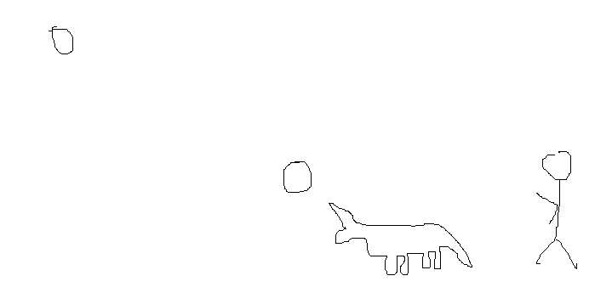**3 Concept, Sketch & Inspiration**

**4**

|  |  |  |
| --- | --- | --- |
| When the user: |  | The result is: |
| Space | , | Summon pet to catch ball |
|  | , |  |
|  | , |  |
|  | , |  |
|  | , |  |

**Features**

**5**

**Accessibility** In order to make this app accessible to as many users as possible:

|  |  |
| --- | --- |
| - | Free to play |
| -  - | Publish on web |

**6**

|  |  |  |
| --- | --- | --- |
|  | Milestone | Date |
| 1 | - 1 | 04/11/2022 |
| 2 | - |  |
| 3 | - |  |
| 4 | - |  |
| 5 | - |  |

**Timeline**

|  |  |
| --- | --- |
| -  -  -  -  -  -  -  - | Basic gameplay |

**7**

**Backlog features**